**Prepared by: Milad Chowdhury**

**Date: 04/03/2025**

**Module: Secure Software Development1. Functional Testing Evidence**

**User Authentication Testing**

**Test Case:** Successful login as Admin  
**Steps Taken:**

1. Entered admin as username.
2. Entered password as password.
3. Successfully logged in.

**

**Test Case:** Failed login attempt with incorrect credentials  
**Steps Taken:**

1. Entered incorrect username or password.
2. System rejected login.

***

**File Storage & Encryption Testing**

**Test Case:** Successfully stored an encrypted file  
**Steps Taken:**

1. Selected store option.
2. Provided file path: C:\Users\MC\Documents\sample.txt.
3. System-confirmed file encryption and storage.

**Screenshot Evidence:**

**Test Case:** Successfully retrieved and decrypted file  
**Steps Taken:**

1. Selected retrieve option.
2. Entered file ID from list command.
3. The system decrypted the file and saved it as retrieved_sample.txt.

**Screenshot Evidence:**

**Admin\User adding & Exit Testing**

**Test Case:** Successfully added user  
**Steps Taken:**

1. Selected register option.
2. Entered new user Name: test_user
3. Entered guest as password
4. Assigned role as user
5. 'test_User' created a new role, 'user'.

**Screenshot Evidence:**

**Test Case:** Successfully exiting the program

**Steps Taken:**

1. Selected exit option and Enter

**Screenshot Evidence:**

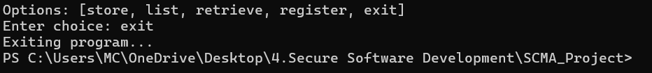

**2. Security Testing**

**Security Testing with Bandit**

**Command Used:** bandit -r .

**

**Results:** No security vulnerabilities detected.

**Code Quality Testing with Pylint**

**Command Used:**

pylint main.py db_manager.py encryption_manager.py

**Screenshot Evidence:**

**Final Pylint Score:** 9.47/10

**PEP8 Compliance Check with Flake8**

**Command Used:**

flake8 .

**Screenshot Evidence:**

**Results:** Passed PEP8 compliance with minor fixes.